Name: /50
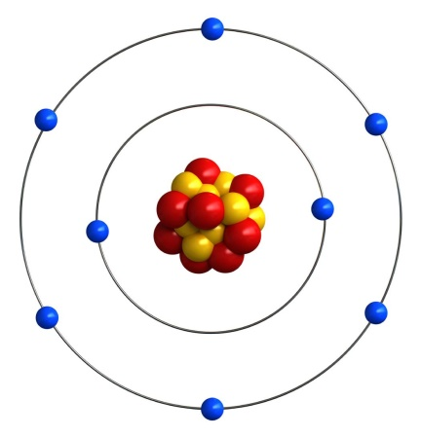
- Use your knowledge of the atom to complete the table below. [4 marks]
Sub-atomic  particle colour | Sub-atomic  particle name | Sub-atomic  particle charge | Sub-atomic  particle weight
Blue
Yellow | Proton
Red

- What is the name and symbol of the element in the model? [1 mark]

- What is the electron configuration of this element? [1 mark]

- What would be the electron configuration of this element if it had a -2 charge? [1 mark]

- Complete the following table using your periodic table. [6 marks]
Name | Symbol | Atomic # | Mass # | Protons | Neutrons | Electrons
Hydrogen
 | K
 |  | 26
 |  |  | 14

- Use the periodic table to write a correct symbol for each of the following. [5 marks]
- The element that is in group 2 and period 4.
- A noble gas with exactly 3 occupied electron shells.
- An element from group 14 that is a non-metal.
- The element in period 3 that has the largest atomic radius.
- The element in group 16 that has the highest electronegativity.

- What are the similarities and differences between isotopes of the same atom? [2 marks]

- Explain why the relative molecular mass of each element is not identical to those found on the periodic table. [2 marks]

- Silver atoms consist of 51.4% of the isotope ¹⁰⁷Ag and 48.6% of the isotope ¹⁰⁹Ag
Calculate the relative atomic mass of silver, rounding your answer to 1 decimal place. [3 marks]

- To determine isotope distributions, a mass spectrometer can be used. A mass spectrometer works in four different phases – ionization, acceleration, deflection, and detection. Describe the first three phases below, explaining why we require each step.
  - Ionization [2 marks]

  - Acceleration [2 marks]

  - Deflection [2 marks]

- At what m/z value (rounded to a whole number) would you expect the following ions to appear at in a mass spectrometer? Using this information, circle the ion that would be detected first. [3 marks]
Na⁺:
Fe³⁺:
- Bohr based his model of the atom on hydrogen, noticing that when exposed to energy it emitted coloured light of specific wavelengths. Explain why this occurs. [4 marks]

- Atomic Absorption Spectroscopy (AAS) can be used to detect incredibly low amounts of various heavy metals. Explain how AAS differs to a typical flame test. [2 marks]

- At a particular crime scene, a man was found murdered at his kitchen table. Suspected to have died of lead poisoning, a forensic scientist decided to use AAS to construct a calibration curve, shown below

- Name the type of hallow cathode lamp the scientist would have used and explain why this specific one is needed. [2 marks]

- The lab results indicated that the water the man drank from had an absorbance reading of 0.35. What was the concentration of lead in the drinking water? [1 mark]

- The NHMRC has a limit of 0.01 mg/L concentration of lead, with anything above this being considered toxic to humans. Determine whether the man was likely to have died from lead poisoning, explaining why. [2 marks]

- Describe and explain the trends in electronegativity down the group and across a period in the periodic table. [5 marks]
- include an explanation for electronegativity in your answer.

